As the first-time author,I explored the gait selection problem for a hexapod robot for analyzing its stability and its kinematics performance.Our hexapod robot is different from the wheeled robot or tracked mobile robot,with the movement principle of tripod gait,it can pass all kinds of complex terrain.In addition, the height of swing-legs or the movement priority would be reordered automatically when blocked.

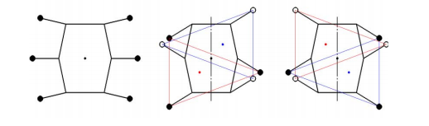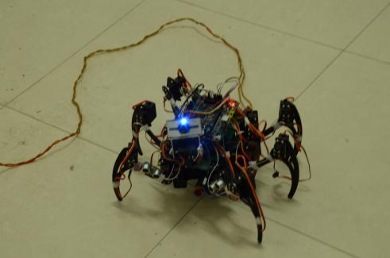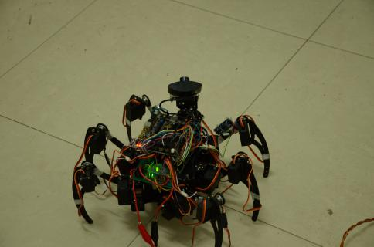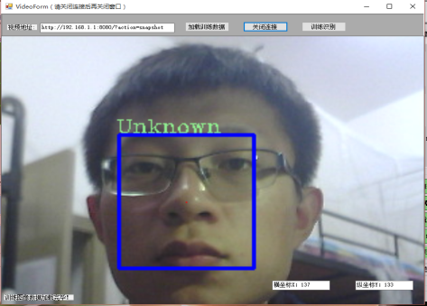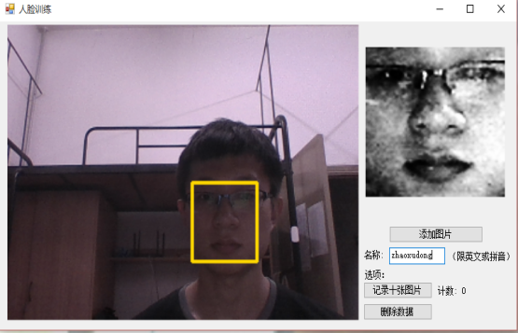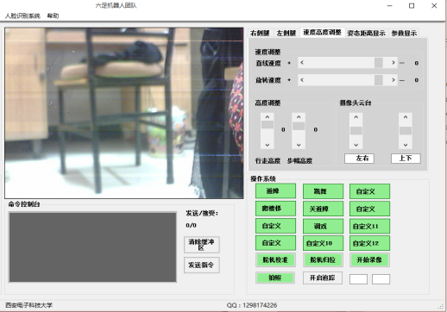 Fig.1 the robot  Fig.2 the robot Fig.3 tripod gait

Fig.4 Human-Computer Interaction Face

Another feature of our robot is the camera could feed back video to the terminal by a router running Openwrt system.In addition,the robot and the Human-Computer Interaction Face adopt two-way serial communication.The terminal transfers instructions to the robot and the robot conveys its state to the terminal in turn. And for the function of security monitoring,we designed the human face detection algorithm.The key content of the algorithm includes training Haar classifier and using the Haar classifier to detect faces.First of all,we need to shoot a film of someone whose face need to be detected and load it into the classifier.If finished,the terminal will detect human faces under the complex background fed back by the robot.

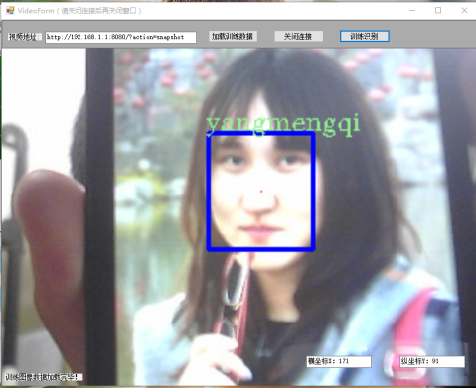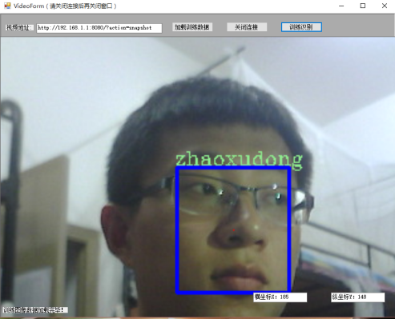 Fig.5 Face Detection Fig.6 Face Detection

The Plan Of Doctoral Research

In my doctoral research,I hope I can form a systematic knowledge view of computer vision and machine learning and roam widely in computer as well as information science and technology.What’s more, as a PhD student,it is essential to have valuable propositions and forward-looking thoughts. Besides,I should participate in subjects with tutors as soon as possible to raise the level of scientific research and master the methods.

As for paper,it is vital to finish the first one early.I should train myself to have either symbolic logic or language ability to think logically and to finish paper well.In particular,a strong sense of cooperation is essential for a PhD student,just as an old notion goes that “Two heads are better than one”.In addition,the tutor is a guide along the road of science,so I should give regular periodical reports to my tutor and take guidance at the same time.

I’ve always had a passion for computer vision and machine learning,so I hope to bury myself in this field over the next few years.Maybe I could be nominated for the outstanding doctoral paper.

Thanks again for the reply and may you best wishes.